# Climate change data analysis based on World Bank data

The analysis report is useful in various ways, such as it helps in identifying how an increase in population may affect social and economic factors and also helps in understanding the environmental impact on land, deforestation, etc. The analysis done will also be helpful even in the future when combined with another dataset. This analysis report will help in understanding the relationship between urbanization and economic and social development.

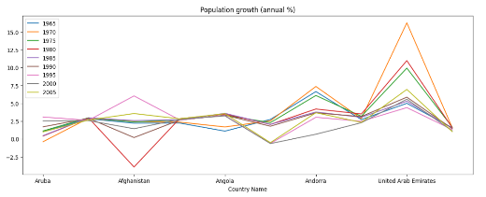The plot showing population growth (annual %) of the year 1965 to 2005 for Aruba, Afghanistan, Angola, Andorra, United Arab Emirates can be used to analyze and understand the trends of population growth in different countries. This can be useful in identifying countries that may face challenges such as overpopulation, lack of resources, and potential environmental impacts of population growth.

This analysis can also be used to understand how population growth rates interact with other economic and social factors, such as poverty, education, and health. By identifying correlations between population growth rates and these other factors, policymakers and researchers can develop strategies to promote sustainable and equitable economic and social development.

Additionally, as more data becomes available, this analysis can be expanded to include a wider range of countries and time periods, allowing for more detailed and nuanced insights into population growth trends at the global and regional levels. This can help to inform policy decisions related to population planning, resource management, and economic and social development.

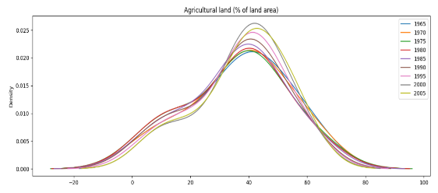The analysis performed by this code can be useful for understanding the trends and patterns of agricultural land use across different countries and regions. By analyzing the percentage of land used for agriculture, policymakers and researchers can identify areas where agricultural development is necessary to ensure food security and sustainable economic growth.

The code selects the rows in the dataset where the "Indicator Name" is "Agricultural land (% of land area)" and groups the data by "Country Name" to calculate the total agricultural land use for each country. It then selects the first 15 countries and plots a kernel density estimate of the agricultural land use percentage from 1965 to 2005.

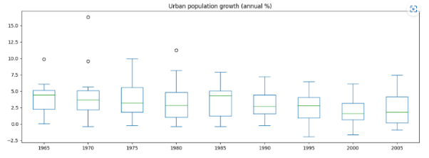In the future, this analysis can be expanded to include a wider range of countries and time periods and can also be combined with other datasets to understand the relationships between agricultural land use, food production, and economic development. For example, by combining this data with information about crop yields and agricultural productivity, researchers can identify countries and regions where agricultural development is necessary to meet the growing demand for food.

This analysis can also be used to understand the environmental impacts of agricultural land use, such as soil erosion, deforestation, and greenhouse gas emissions. By identifying countries and regions with high levels of agricultural land use and potential environmental impacts, policymakers and researchers can develop strategies to promote sustainable land use practices and reduce the environmental footprint of agriculture.

The analysis performed by this code can be useful for understanding the patterns and trends of urban population growth across different countries and regions. By analyzing the annual percentage change in the urban population, policymakers and researchers can identify areas where urbanization is occurring rapidly and plan for the associated infrastructure and resource needs. The code selects the rows in the dataset where the "Indicator Name" is "Urban population growth (annual %)" and groups the data by "Country Name" to calculate the total urban population growth rate for each country. It then plots a boxplot of the urban population growth rate from 1965 to 2005.

In the future, this analysis can be expanded to include a wider range of countries and time periods and can also be combined with other datasets to understand the relationships between urbanization, economic development, and social and environmental factors. For example, by combining this data with information about urban land use patterns, infrastructure development, and social and economic indicators, researchers can identify areas where urbanization is occurring rapidly and plan for the associated resource needs, such as housing, transportation, and water and sanitation infrastructure.

This analysis can also be used to understand the environmental impacts of urbanization, such as air and water pollution, urban heat islands, and greenhouse gas emissions. By identifying areas with high rates of urbanization and potential environmental impacts, policymakers and researchers can develop strategies to promote sustainable urban development and reduce the environmental footprint of cities.

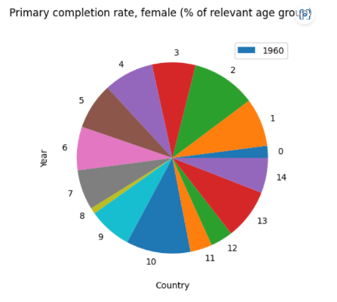The code appears to have some errors, as it is attempting to create a pie chart of a single data point (the "2020" value for "Primary completion rate, female (% of relevant age group)"). However, assuming the code is corrected, the resulting analysis can provide insights into the current state of female education around the world.

By analyzing trends in primary completion rates for females, researchers and policymakers can identify areas where access to education is limited and develop strategies to promote educational equity and gender equality. This analysis can also be combined with other data, such as enrollment rates, educational attainment, and social and economic indicators, to understand the complex factors that influence educational outcomes for girls and women.

In the future, this analysis can be expanded to include a wider range of countries, time periods, and educational indicators, such as secondary and tertiary enrollment rates, literacy rates, and educational attainment by field of study. By analyzing these data together, researchers can identify areas where educational access and outcomes are most limited and develop targeted interventions to address these challenges

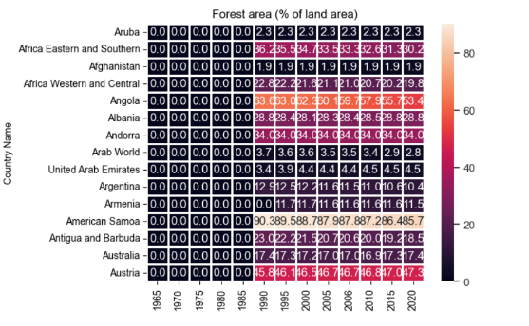In the future, analyzing forest area (% of land area) can provide insights into the changes in forest cover and management practices around the world. It can help in identifying areas that need reforestation or afforestation programs and also track progress in forest conservation efforts. This data can be used in policymaking, planning and decision-making for sustainable development and climate change mitigation. With the growing concerns over climate change and biodiversity loss, monitoring forest cover is crucial to achieving the targets set by global agreements such as the Paris Agreement and the Sustainable Development Goals. As such, continued monitoring and analysis of forest area data will remain important in the future.

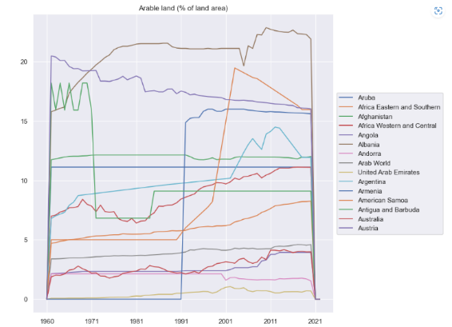In the future, there may be changes in the way data is collected and reported for the indicator "Arable land (% of land area)". There could be improvements in the accuracy and coverage of data, as well as advancements in technology and methods used for data collection. Additionally, there may be changes in policies and practices related to land use, agriculture, and environmental conservation that could affect the trends and patterns observed in the data. It is important to continue monitoring and analyzing this indicator over time to understand how it is changing and to inform decision-making related to sustainable land use and food security.

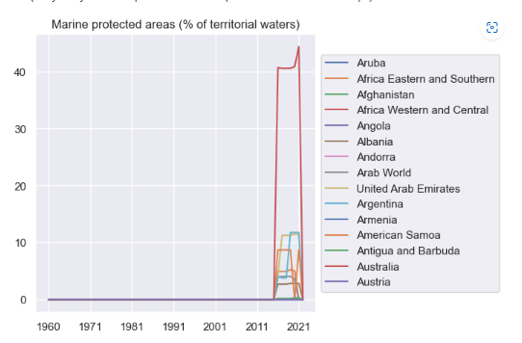In the future, there may be changes in the extent and quality of marine protected areas around the world, which could affect the trends and patterns observed in the data. There could be advancements in technology and methods used for monitoring and assessing the effectiveness of marine protected areas, which could provide more accurate and comprehensive data. Additionally, there may be changes in policies and practices related to marine conservation and management that could affect the establishment and management of marine protected areas. It is important to continue monitoring and analyzing this indicator over time to understand how it is changing and to inform decision-making related to sustainable use and conservation of marine resources.